

Practices for Secure Software Report

Table of Contents
Document Revision History 3
Client 3
Instructions 3
Developer 4
1. Algorithm Cipher 4
2. Certificate Generation 4
3. Deploy Cipher 4
4. Secure Communications 4
5. Secondary Testing 4
6. Functional Testing 4
7. Summary 4
8. Industry Standard Best Practices 4

Document Revision History

Version | Date | Author | Comments
1.0 | October 14, 2026 | Domenic Ferraro

Client



Instructions

Submit this completed practices for secure software report. Replace the bracketed text with the relevant information. You must document your process for writing secure communications and refactoring code that complies with software security testing protocols.

- Respond to the steps outlined below and include your findings.
- Respond using your own words. You may also choose to include images or supporting materials. If you include them, make certain to insert them in all the relevant locations in the document.
- Refer to the Project Two Guidelines and Rubric for more detailed instructions about each section of the template.

Developer
Domenic Ferraro

Algorithm Cipher

Recommended design: use SHA-256 for the required file/data checksum and TLS for communications confidentiality and integrity. SHA-256 is part of the SHA-2 family and produces a fixed 256-bit (32-byte) digest, normally represented as 64 hexadecimal characters. It processes data in 512-bit blocks and uses a 256-bit internal state. It is cryptographic hash, not an encryption cipher: it is one-way and has no decryption key. A receiver can independently hash the same bytes and compare the digest to detect accidental or unauthorized changes, provided the expected digest itself is trusted.
For transport, HTTPS uses TLS, which negotiates a cipher suite. Modern TLS commonly uses ephemeral ECDHE for key agreement, a server certificate for identity, and authenticated symmetric encryption such as AES-128-GCM/AES-256-GCM or ChaCha20-Poly1305. Symmetric session keys are efficient for bulk data; public/private-key cryptography supports authentication and key establishment. Cryptographically secure random numbers are needed for nonces, ephemeral key material, and other protocol values; ordinary pseudo-random application values must not be used for key generation. The local demo certificate uses an RSA 3072-bit key and SHA-256 signature, but production should use a certificate from a trusted and protected CA and protected key storage.

Historically, DES (56-bit key) and MD5/SHA-1 have become unsuitable for modern security because of key-size limitations or collision weaknesses. AES, standardized in 2001 with 128-, 192-, or 256-bit keys, remain widely used; SHA-2 remains broadly accepted for integrity hashing. TLS 1.2 and TLS 1.3 are the modern protocol versions. Algorithm selection should follow current standards and organizational policy, and dependencies must be patched. The endpoint’s fixed sample data is for demonstration only; a checksum by itself does not authenticate the sender. For tamper-resistant file verification in a hostile setting, protect the expected digest with a MAC, digital signature, or authenticated protocol.

Certificate Generation
Insert a screenshot below of the CER file.

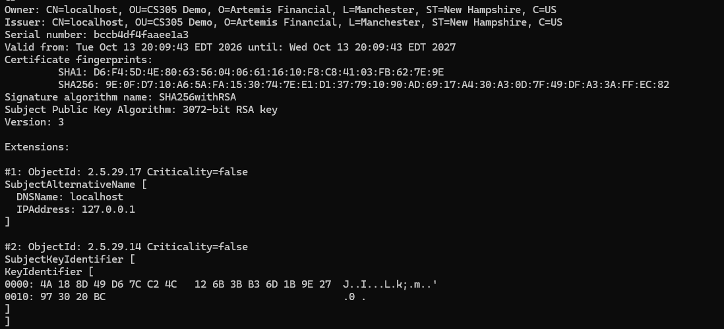

Deploy Cipher
Insert a screenshot below of the checksum verification.

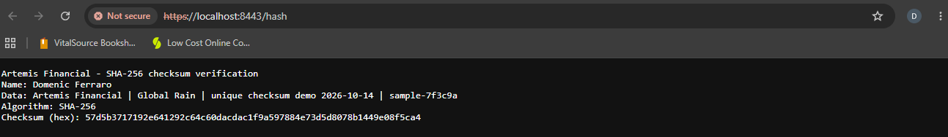

Secure Communications
Insert a screenshot below of the web browser that shows a secure webpage.

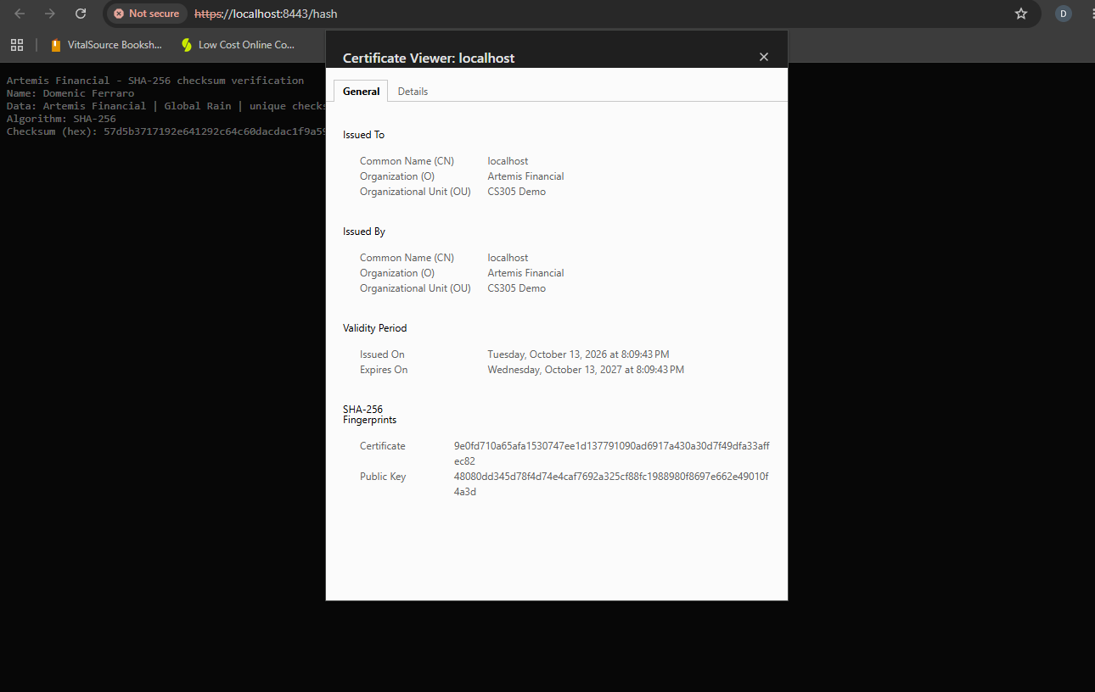

Secondary Testing
Insert screenshots below of the refactored code executed without errors and the dependency-check report.

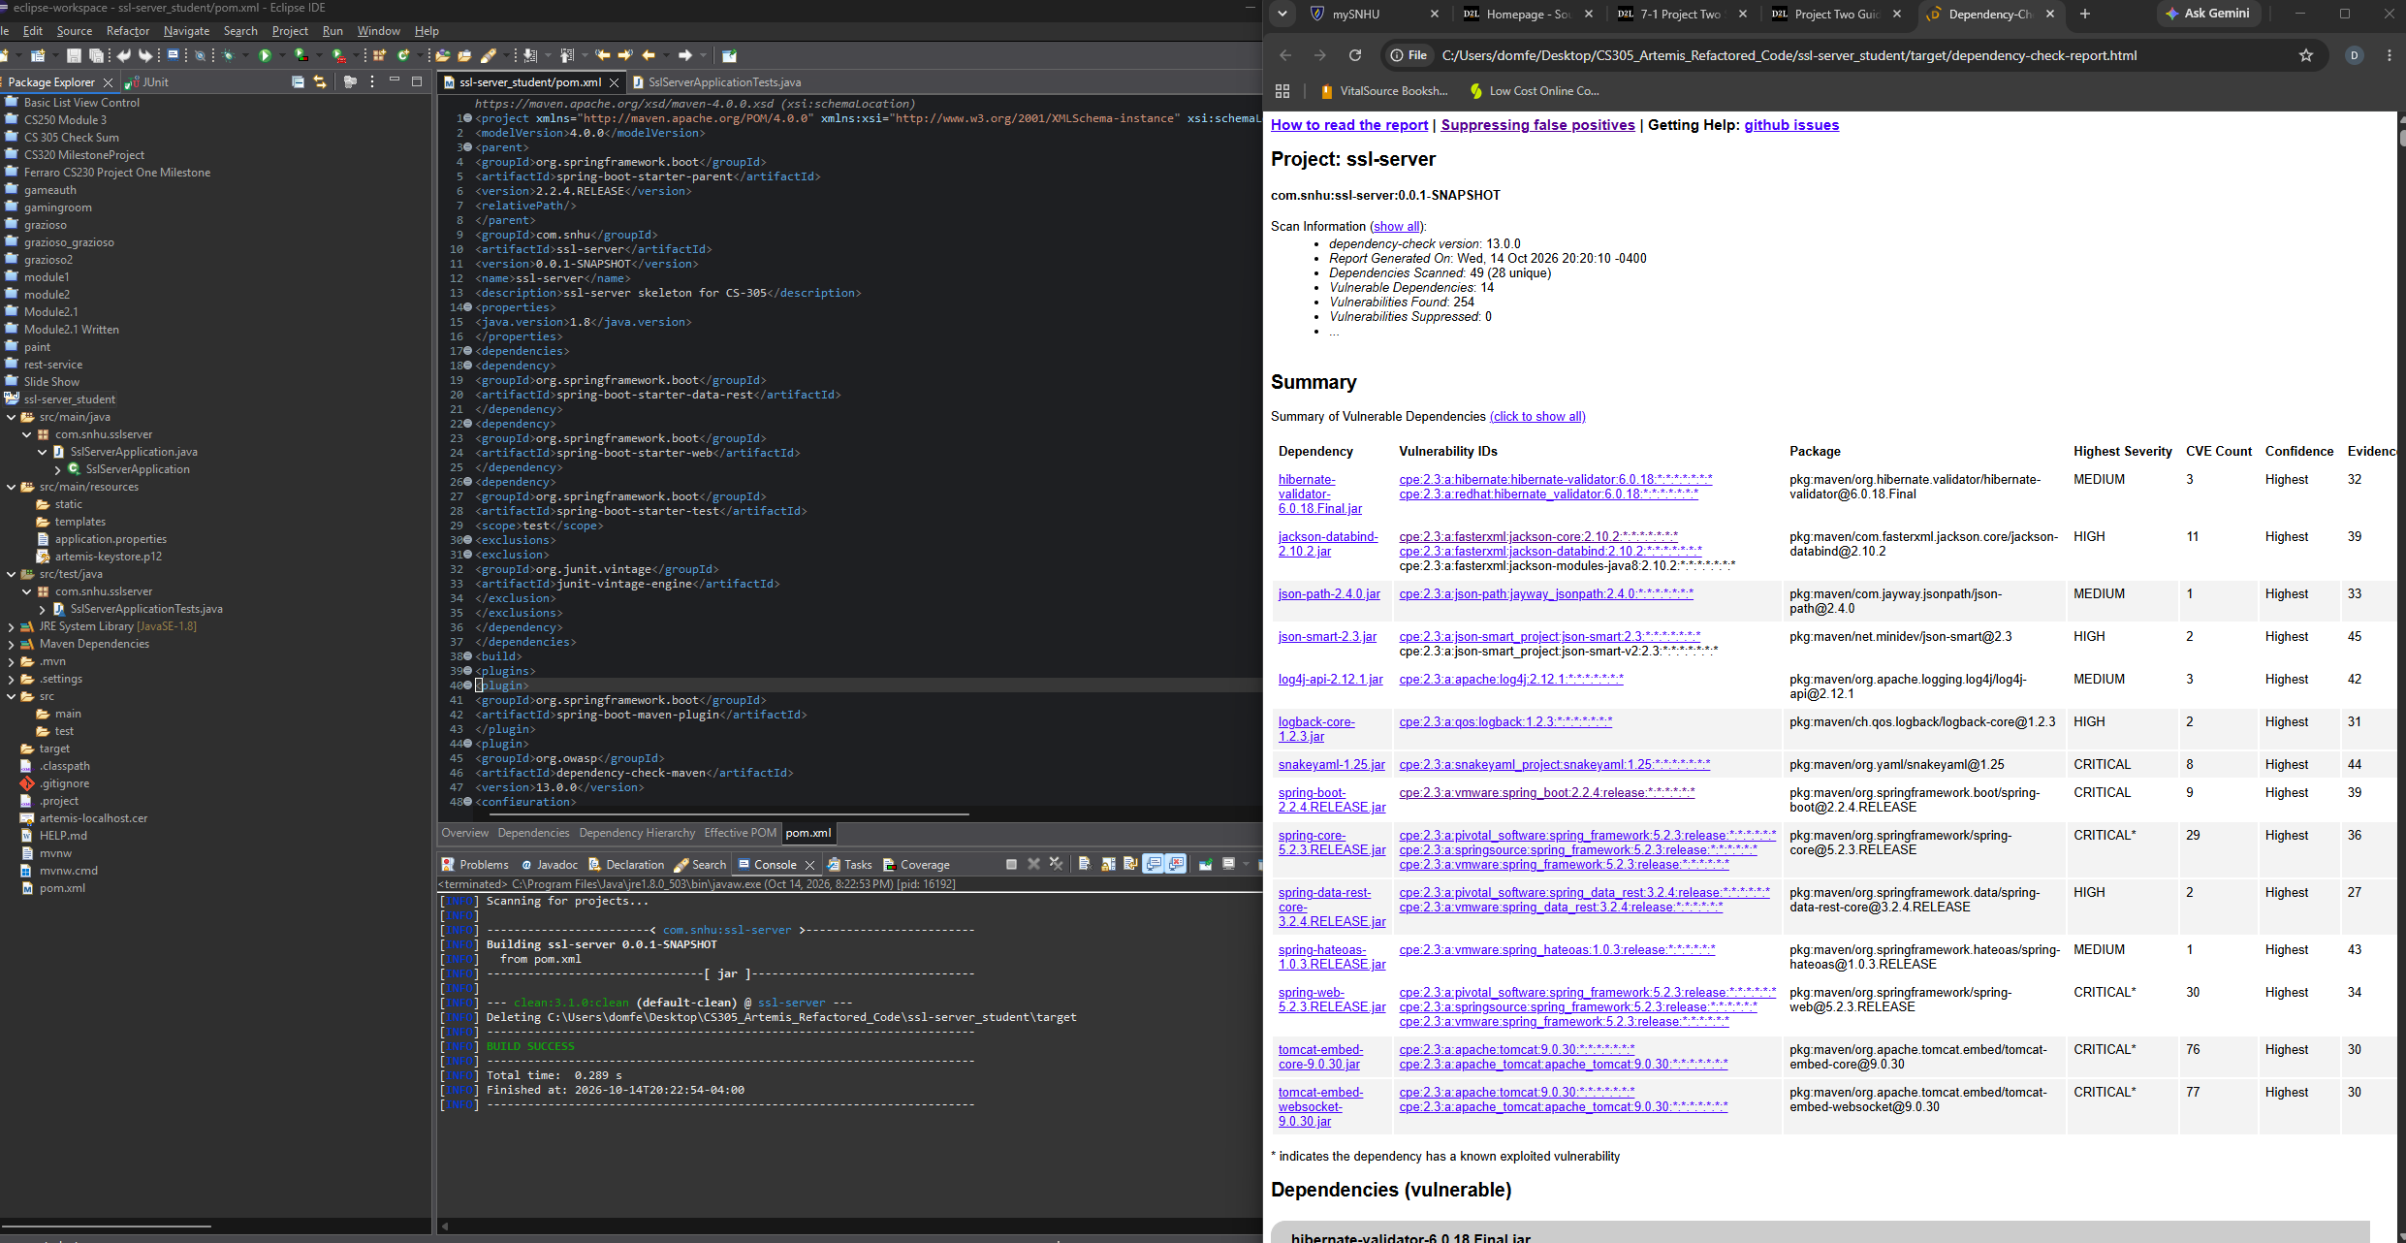

Functional Testing
Insert a screenshot below of the refactored code executed without errors.
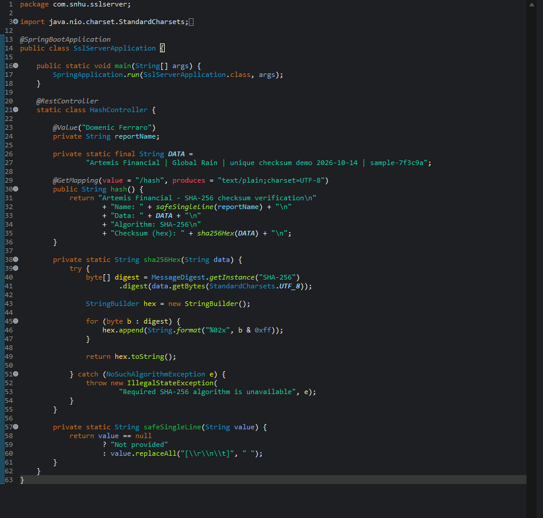

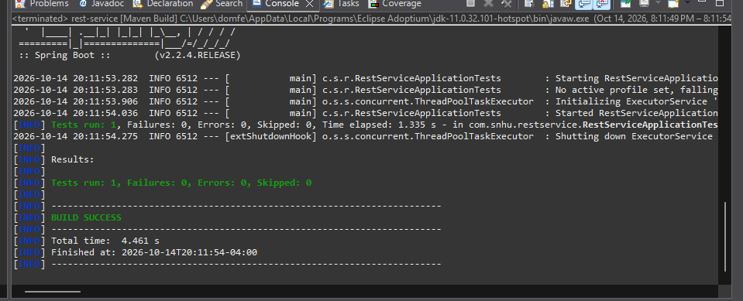

Summary

The starter application was refactored to expose a ‘/hash’ endpoint that returns a SHA-256 digest for a fixed, non-sensitive demonstration string. HTTPS is enabled on port 8443 using a PKCS#12 keystore and a self-signed localhost certificate. The certificate includes DNS ‘localhost’ and IP ‘127.0.0.1’ subject alternative names. The public certificate was exported as ‘artermis-localhost.cer’. The default keystore password and certificate are for local coursework only and must not be used in production.

The vulnerability-assessment flow was addressed through secure design and implementation (selecting a standard hash and HTTPS), code refactoring (hashing UTF-8 bytes and formatting the digest in lowercase hexadecimal), testing (known-answer SHA-256 test and application context test), and dependency analysis (OWASP Dependency-Check configuration). The application has layered controls: TLS protects data in transit, SHA-256 supports content-integrity comparison, a certificate represents the server identity, and automated tests and dependency scanning support ongoing validation. These controls address different risks and do not replace each other.

Industry Standard Best Practices

Secure coding practices applied include using Java’s standard ‘MessageDigest’ implementation rather than a custom cryptography; explicitly encoding the sample string as UTF-8; using SHA-256 instead of deprecated MD5/SHA-1; returning a deterministic hexadecimal digest; limiting the endpoint to a fixed, non-sensitive demonstration payload; sanitizing the configurable name to a single line; and failing closed if SHA-256 is unavailable. HTTPS is configured explicitly with a PKCS#12 keystore and TLS 1.2/1.3. Tests include a known SHA-256 test vector (‘abc’) and a Spring application context test. The Maven configuration uses a current Spring Boot 3.x line and OWASP Dependency-check plugin configuration.

The report does not claim that a dependency scan is clean: run the scanner, inspect its HTML report, triage findings, update affected dependencies, and rerun until the result is understood. A self-signed certificate triggers browser trust warnings and is appropriate only for a local demonstration. In production, use a trusted CA certificate, keep private keys and passwords out of source control, store secrets in a secret manager, enforce TLS policy, monitor dependencies, and retest after updates. Industry-standard practices reduce the likelihood and impact of data exposure, service compromise, regulatory issues, remediation costs, and loss of customer trust. Security is an ongoing lifecycle responsibility, not a one-time code change.

